Estimated time to complete this lab: **60 minutes.**

Create a React App named “bloggerapp” in with 3 components.

1. Book Details
2. Blog Details
3. Course Details

Implement this with as many ways possible of Conditional Rendering.

**App.js**

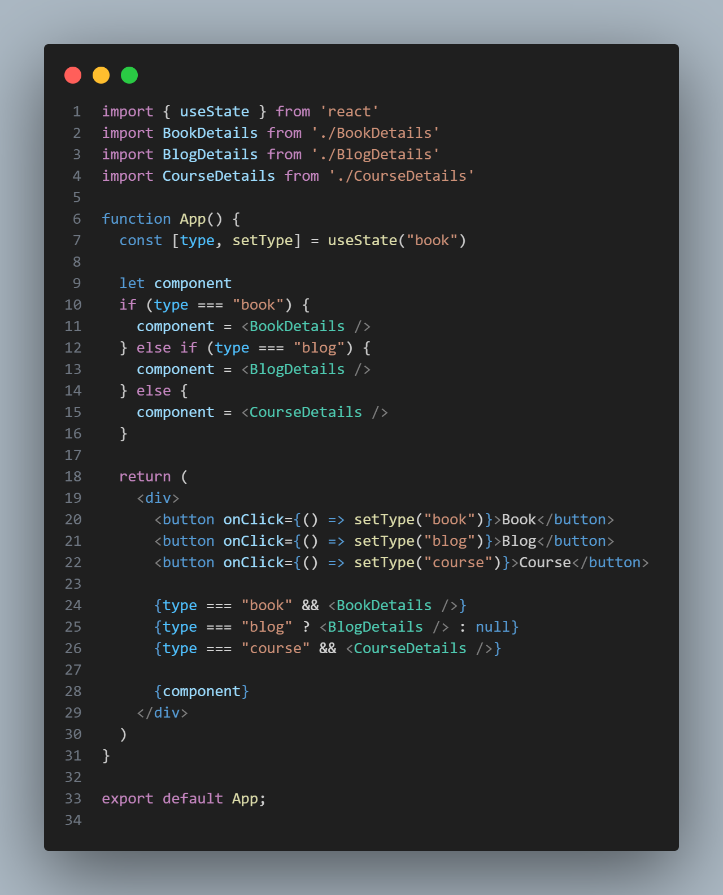

**BlogDetails.js**

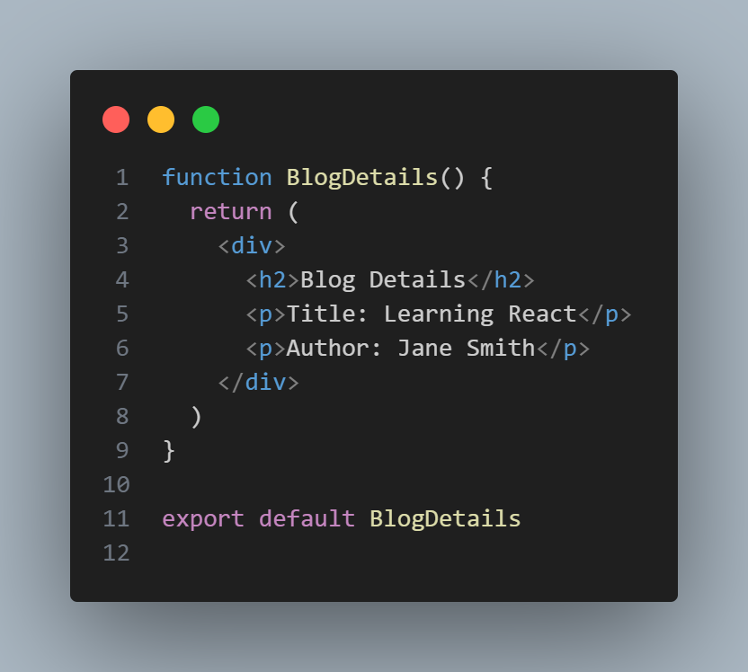

**BookDetails.js**

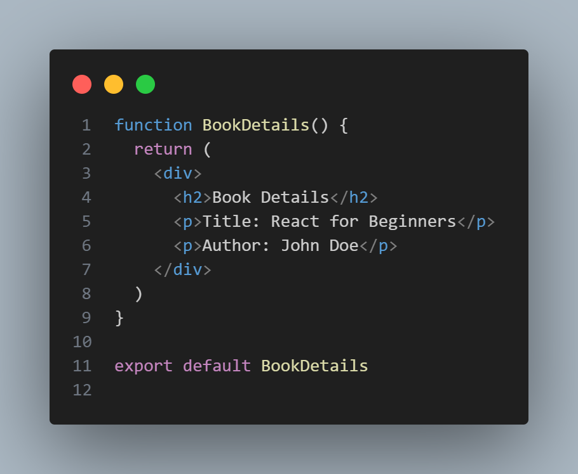

**CourseDetails.js**

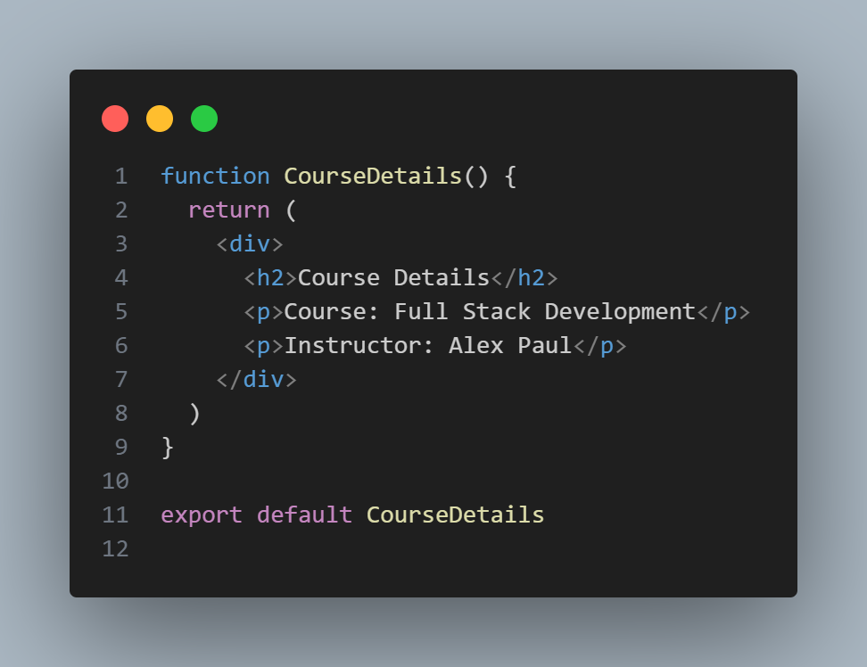

OUTPUT

